**Syed Arham Ahmed (22i-1552)**

**Muhammad Azan (22i-1668)**

**Muhammad (22i-1612)**

**DLD Project Report**

**“Traffic Lights”**

This circuit turns ON green LED, keeps it ON for some time, then turns ON yellow LED for a moment and finally turns ON red LED for almost the same duration as the green LED. This cycle again starts from green LED.

**Components Required**

* 2 x 555 Timer ICs
* LEDs: 1 Red, 1 Yellow, 1 Green
* Resistors: 100K, 47K, 2 x 330R, 180R
* Capacitors: 2 x 100uF
* Breadboard
* Few Breadboard Connectors
* (5-12) V Power Supply

## How This Circuit Works

We have used two such astable circuits with the first astable circuit powering the other. So the second 555 timer IC will be powered only if the output of first 555 timer IC is ON.

The red LED is connected such that it turns ON only if the output of first 555 timer IC is at 0V. This is because the other terminal of red LED is connected to positive voltage. Yellow LED turns ON during discharge mode of second 555 IC, and the green LED turns ON whenever the output of second 555 timer IC is at positive voltage.

Immediately after we power ON this circuit, output of the first 555 timer IC will be in ON state because the voltage at PIN-3 (Trigger Pin) is less than 1/3rd of the supply voltage. The red LED cannot turn ON yet, but the second 555 IC is powered and so the green light turns ON.

The capacitor of 2nd 555 timer IC slowly charges and as soon as it charges to 2/3rd of the supply voltage (Threshold Voltage), the output of 2nd 555 IC turns OFF and the yellow LED glows because the discharge pin is activated.

Normally the yellow LED would turn ON for the same time as the green LED. But even before the capacitor of 2nd 555 timer IC reaches 1/3rd of supply voltage, the voltage across capacitor of 1st 555 timer IC reaches 2/3rds of the supply voltage and so the output of 1st 555 IC turns OFF, resulting in yellow LED turning OFF and the red LED turning ON.

This cycle repeats again and again.

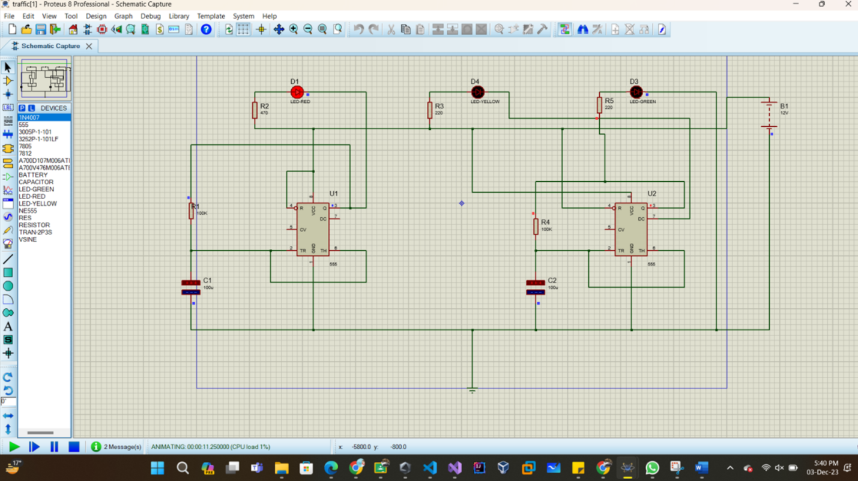

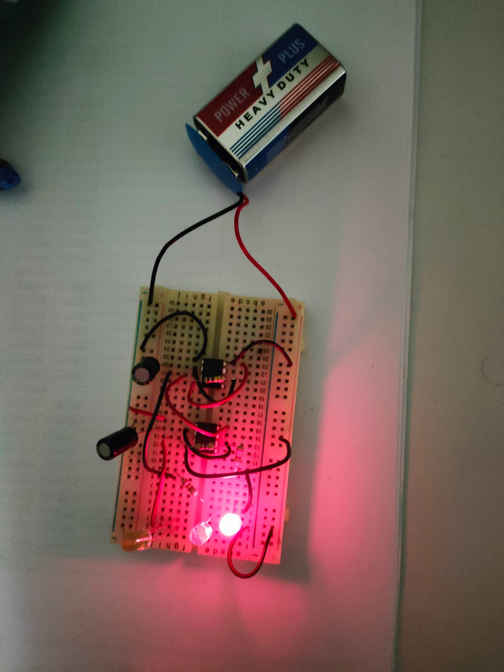

## How we implemented the circuit on bread board

Took one rail as positive and one as negative, then we placed a 555 timer IC on the bread board and connected its pin 8 to +ve and pin 1 to -ve. Then we connect pin 2 and 6 of the IC together along with pin 4 and pin 8 to each other. Now use a 100k resistor between pin 6 and 3, and 100micro farad capacitor between pin 2 and -ve, such that the +ve of capacitor is connected to pin 2.

Now place the second 555 timer IC on the bread board and connect its pin 8 to pin 3 of the first 555 timer IC. Connect pin 1 to -ve and pin 2 and pin 6 to each other. Then connect pin 4 to +ve. Now connect a 47K resistor between pin 6 and pin 3 of the second 555-timer IC. Now place a 100 micro farad capacitor between pin 2 and -ve rail. Now place a red and a yellow led on the bread board so that their cathode pins are in different columns and the anode pins are in the same column. Now connect their anode pins to +ve. Now connect pin 3 of the first IC to cathode pin of red led by a series resistor. Connect the cathode pin of the yellow led to the pin7 of the second 555 timer IC using another series resistor. Place the green led on the bread board and connect its anode pin to the second 555 timer IC and its cathode pin to -ve using a series resistor. Now we will connect the power supply and boom! Your traffic light will start working.